Behaviour Policy

Junior and Senior Domestic Competitions

Zero Tolerance Policy & Technical Foul Policy

- About the Sunbury Basketball Association Inc
Established in 1975, the Sunbury Basketball Association Inc (“SBA”) is a diverse and inclusive not-for-profit community hub, serving over 3,200 members from a wide range of backgrounds and abilities. The SBA operates across seven basketball venues.
The SBA’s inclusivity is central to its mission, engaging individuals from ages 5 to 80 years, and ensuring basketball is accessible to everyone, whether they are beginners or elite athletes.
The SBA’s range of basketball programs is specifically designed to meet the needs of a diverse community, from those seeking a fun recreational experience to those pursuing higher-level elite competition. Programs conducted ensure that all, regardless of gender, ability, or background, have opportunities to participate.
The SBA comprises eleven domestic clubs, each operating under the Associations Incorporated Act 2009. These clubs are the backbone of the SBA, recruiting players, coaches, team managers and technical officials, while electing representatives to sit on the Domestic Competition sub-committees. The SBA also includes the Sunbury Jets, its representative arm, providing players with high-level state/national competition opportunities.
The SBA’s inclusive approach extends to all clubs, ensuring that every member, regardless of ability or background, has access to opportunities to participate and excel in basketball.
Our Vision: Fostering the finest community-based environment where basketball is the preferred sport of choice
Our Mission: Collaborate and provide a well-defined pathway for all participants to achieve their personal best

Our Values: Accountability, Integrity, Respect, Inspiration, Inclusivity, Leadership
- Behaviour Policy Overview

The SBA is committed to providing a safe, respectful and enjoyable environment for all participants, including players, coaches, team officials, referees, scorers, parents, guardians and spectators.

In September 2022, the SBA introduced a Zero Tolerance Policy to address inappropriate behaviour from parents, guardians and spectators.

Effective 1 October 2025, the SBA Behaviour Policy operates under a two-part framework:
- Zero Tolerance Policy – Applies to parents, guardians, spectators and scorers.
- Technical Foul Policy – Applies to players, coaches, assistant coaches and team managers.

All persons entering SBA-controlled venues represent their team, their club and the broader basketball community. Respectful and appropriate behaviour is expected at all times. The SBA maintains zero tolerance for inappropriate, abusive or unsporting conduct.
- Zero Tolerance Policy - Parents, Guardians, Spectators & Scorers
3.1 Authority to Enforce
The following SBA representatives are authorised to enforce this policy:
- Referee Advisors
- Referee Coaches
- Referee Supervisors
- SBA Board Members
- Junior and Senior Domestic Committee Members
- Life Members
- Tribunal Panel Members
- SBA Staff Members
These representatives may direct any parent, guardian or spectator to immediately leave the venue if they witness behaviour including, but not limited to:
- Persistently or wilfully questioning or challenging decisions made by referees or scorers
- Verbally abusing or intimidating referees or scorers
- Verbally abusing team officials (their own or the opposition’s)
- Verbally abusing other parents or spectators
- Verbally abusing any game day or venue official
- Engaging in conduct inappropriate in a sporting or community environment
- Wilfully damaging or removing SBA or personal property

3.2 Failure to Comply
If a person refuses to comply with a direction to leave, the venue supervisor may contact Victoria Police if required.

3.3 Further Sanctions
A parent, guardian or spectator directed to leave may:
- Be suspended by the SBA Board
- Be referred to a Basketball Victoria Tribunal
Repeated inappropriate behaviour may result in further sanctions, which could include consequences affecting the relevant player or team.
The SBA Office will notify the relevant club in writing of any Zero Tolerance Policy enforcement.
Notification will be provided via email to:
- The Club Secretary
- The Club President
- The relevant Junior or Senior Domestic Competition (JDC/SDC) Representative
All communication with the relevant player, coach, parent, guardian or spectator must occur via the club. The SBA will not enter into direct correspondence with individuals regarding actions taken under this Policy.
The process for managing and administering Zero Tolerance incidents is further supported by the SBA Incident Flowchart, which operates in conjunction with this Policy.

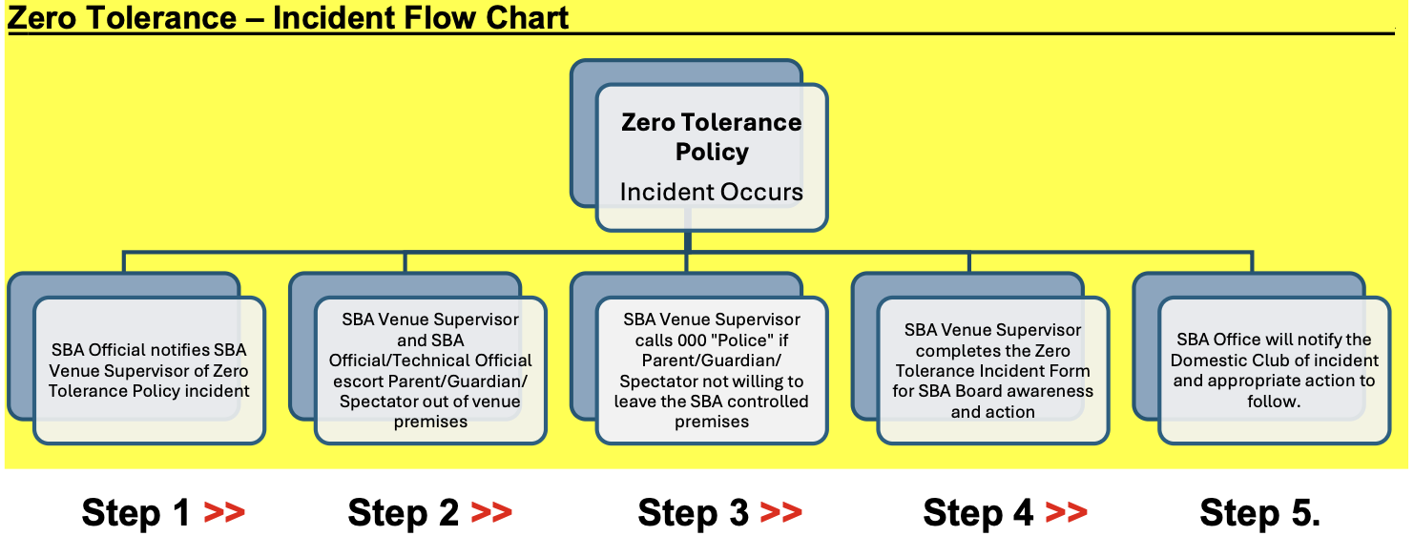

- Technical Foul Policy: Players, Coaches, Assistant Coaches and Team Managers

4.1 Immediate Game Sanctions
Any player, coach or team official issued with a Technical Foul must immediately leave the court and take no further part in the game for five (5) minutes of playing time.
If an individual receives two (2) Technical Fouls in the same game, they are immediately disqualified and must leave the playing and spectator area for the remainder of the game.
Where a bench Technical Foul cannot be attributed to a specific individual, it will be recorded against the head coach.
All Technical Fouls issued in SBA-controlled games will be recorded on the PlayHQ game summary and maintained by the SBA Competitions Team.

4.1 Definition and Scope of Technical Fouls
For the purposes of this Policy, a Technical Foul is issued for behavioural conduct that is deemed inappropriate, unsporting or contrary to the values of the SBA. This includes, but is not limited to, dissent, disrespect towards officials, or inappropriate on-court or bench behaviour.
- Technical Fouls are distinct from other foul types under the official rules of basketball. In particular:
An Unsportsmanlike Foul relates to illegal basketball contact during play and is not classified as a Technical Foul under this Policy.
- A Disqualifying Foul relates to serious misconduct and results in immediate removal from the game but is not classified as a Technical Foul Incident for the purposes of escalation under this Policy.
Notwithstanding the above, any conduct resulting in a Disqualifying Foul may be subject to further disciplinary action by the SBA, including referral to the SBA Board or the Basketball Victoria Tribunal, where deemed appropriate.

4.3 Definition of an “Incident”
For the purposes of this policy, an Incident is defined as one game in which a Technical Foul is recorded, regardless of the number issued within that game.

4.4 Escalating Penalties
Upon receiving a Technical Foul Incident, the individual will be notified via email through their Club Secretary and Club Delegate and subject to the following:
- 1st Incident – Written Warning
- 2nd Incident – Automatic Two (2) Week Suspension
- 3rd Incident – Automatic Four (4) Week Suspension
- 4th Incident – Automatic Six (6) Week Suspension and referral to the SBA Board for consideration of membership removal and/or future registration restrictions
The above process does not prevent a matter from also being referred to the Basketball Victoria Tribunal where deemed appropriate.

4.5 Notification of Technical Foul Incidents and Suspensions
The SBA Office is responsible for the administration and communication of all Technical Foul Incidents and resulting sanctions under this Policy.
Where a Technical Foul Incident results in a suspension (including where a participant receives two (2) Technical Fouls in a single game and is disqualified), the SBA Office will notify the relevant club in writing.
Notification will be provided via email to:
- The Club Secretary
- The Club President
- The relevant Junior or Senior Domestic Competition (JDC/SDC) Representative
This notification will confirm the details of the incident and any applicable sanction.
It is the responsibility of the club to notify the affected player, coach or team official of the suspension. All communication to the individual must be managed by the club, and not directly by the SBA.
The process for recording, reviewing and administering Technical Foul Incidents is further supported by the SBA Incident Flowchart, which operates in conjunction with this Policy.
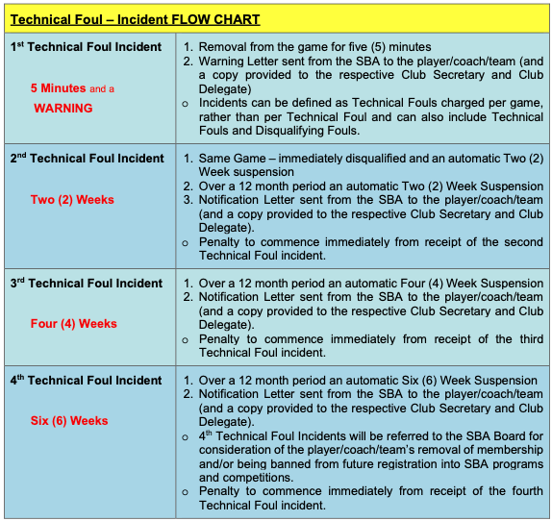
4.6 Suspension Conditions
A person suspended under this policy:
- May not play, coach, score or act in any official capacity
- May not sit on or behind the team bench
- May not perform any of the above roles for any team
- Must not participate in SBA-controlled competitions during the suspension period
Suspensions will be recorded on the individual’s PlayHQ profile for administrative and governance purposes.
If a suspended person is found to be playing, coaching, scoring or sitting on the team bench during their suspension, the following consequences will apply:
- An additional one (1) week suspension will be added for each match in which the individual participates while suspended.
- Additional suspension periods are cumulative and will be served consecutively, commencing only after the original suspension period has been completed.
- This means the individual must first serve the full original suspension, with any additional matches added to the end of that suspension period.
- If the individual participates in three (3) or more matches while suspended, the matter will be referred to the SBA Tribunal for further disciplinary action, which may include additional suspension or other sanctions.
- The SBA Board reserves the right to apply further consequences where deemed appropriate.

- Appeals Process
Players, coaches and team officials may appeal a Technical Foul Policy penalty to the SBA Board within 36 hours of receiving written notification.
Appeals must:
- Be submitted in writing
- Be lodged by the Club Secretary or Club Delegate only
- Be sent to domestic@sunburybasketball.com.au
- Include significant new or additional evidence
Any suspension imposed under this policy will remain in effect unless or until the appeal is overturned.

5.1 Initial Review Process (Delegated Authority)
All Behaviour Policy appeals will first undergo a formal SBA staff-led review under delegated authority of the SBA Board.
The review panel will consist of:
- The SBA Domestic Competition Officer
- The SBA Technical Program Development Officer
- With support from the SBA Business Manager
This panel is authorised by the SBA Board to review, assess and determine Behaviour Policy appeals at first instance.
The panel will collate and assess all relevant information relating to the appeal, including but not limited to:
- The submitted Behaviour Policy Appeal Form
- The appellant’s supporting letter
- Any witness statements provided
- The referee(s)’ account of the incident
- Clarification of any claims made within the appeal
- Any relevant competition records (including PlayHQ reports)
Following review, the panel will:
- Determine whether the appeal is upheld or denied; and
- Issue a written outcome to the appellant via their Club Secretary and Club Delegate.
The review panel will endeavour to determine and communicate the outcome prior to the next scheduled game in which the player is eligible to participate in that competition.
Any suspension imposed under this Policy will remain in effect until the written outcome of the appeal is issued. Where a player participates in multiple teams or competitions, the suspension will apply to all relevant fixtures until the appeal outcome is determined.
The determination made at this stage constitutes the SBA’s formal first-instance decision under this Policy.

5.2 Escalation to SBA Board
If the appellant wishes to escalate the matter following receipt of the SBA’s formal first-instance decision under Section 5.1, and does not accept that outcome, a further appeal may be lodged to the SBA Board in accordance with SBA Bylaw 7.1. Any such appeal must be formally endorsed by their club. The Board may:
- Affirm the original decision
- Vary the penalty
- Overturn the decision
- Refer the matter for further investigation
Where a matter is escalated to the SBA Board, the original suspension will remain in effect pending the Board’s determination.
As the SBA Board is comprised of volunteer members, the timing of a final determination will depend on member availability to properly review the matter. While every effort will be made to consider the appeal as promptly as practicable, this may result in part or all of the suspension being served prior to the Board’s final decision.
The SBA Board’s determination will represent the Association’s final internal decision.

5.3 External Appeal
Following exhaustion of SBA internal processes, the appellant may seek further review through Basketball Victoria where applicable and in accordance with governing regulations.

Policy Statement
The SBA Behaviour Policy exists to protect the integrity of the competition, the wellbeing of participants and the development of players, coaches and officials within a safe, respectful and inclusive basketball environment.
All members and patrons are expected to uphold the SBA’s Vision, Mission and Values at all times.

